**FIRST MILESTONE**

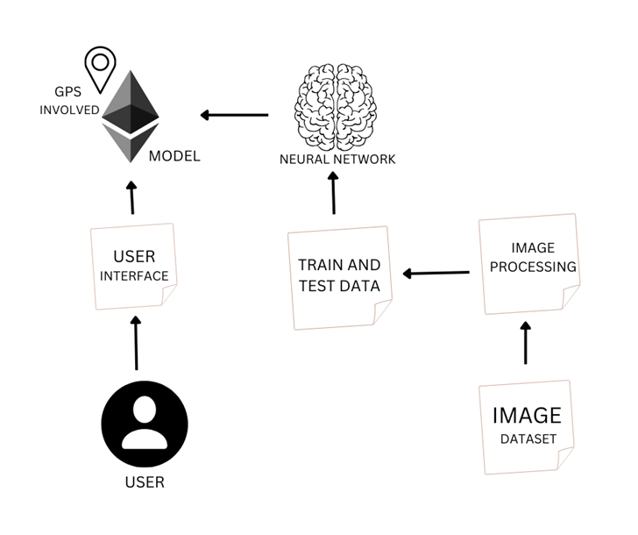Project Theme:

* The main one is that it helps blind people to engage with their social surroundings.
* It provides the person using this technology with information about facial recognition, object recognition or Automatic Speaker Verification.
* The output will be vocal from the device.
* It could also help with other tasks such as navigation